**Front-End UI/UX**

**Mini Project Report**

**1. Title Page**

**Project Title:** Fitness Tracker DashBoard  
**Submitted By:**

* Name: Rhea Tess Payapilly , Pavana M X , Jeevitha A
* Roll Number: 2462137 , 2462178 , 2462079
* College Email ID: [Rhea.tess@btech.christuniversity.in](mailto:Rhea.tess@btech.christuniversity.in) , pavana.mx@btech.christuniversity.in , jeevitha.a@btech.christuniversity.in

**Course:** UI/UX Design Fundamentals  
**Instructor Name:** Nagaveena  
**Institution:** Christ University  
**Date of Submission:** 26/09/2025

**2. Abstract**

This project focuses on designing and developing a **Fitness Tracker Dashboard** using HTML, CSS, JavaScript, Bootstrap, jQuery, and Chart.js. The application enables users to log their daily workouts, track calories burned, and visualize progress through interactive charts. Additionally, users can set weekly or monthly goals and monitor their achievements over time. With a responsive layout powered by Bootstrap, the dashboard adapts to both desktop and mobile devices. The project outcome is a dynamic, user-friendly dashboard that combines interactivity, data visualization, and goal tracking to enhance fitness management.

**3. Objectives**

* Design a clean and responsive fitness dashboard interface.
* Provide a workout log with details like type, duration, and calories burned.
* Integrate progress visualization using charts (line/bar).
* Implement goal setting and progress tracking features.
* Ensure cross-device compatibility with Bootstrap responsiveness.

**4. Scope of the Project**

* **Includes:** Front-end design, workout logging functionality, chart visualization, and goal setting.
* **Excludes:** Backend storage, user authentication, or cloud integration.
* Works seamlessly across devices (desktop, tablet, and mobile).
* Uses HTML, CSS, JavaScript, Bootstrap, jQuery, and Chart.js.

**5. Tools & Technologies Used**

| **Tool/Technology** | **Purpose** |
| --- | --- |
| HTML5 | Content structure and form elements |
| CSS3 | Styling and layout design |
| Bootstrap | Responsive grid system and UI components |
| JavaScript | Logic for workout and goal tracking |
| jQuery | Simplified DOM manipulation and event handling |
| Chart.js | Data visualization using interactive charts |
| VS Code | Code editor |
| Chrome DevTools | Testing and debugging |

**6. HTML Structure Overview**

* <header> with dashboard title and navigation.
* <main> divided into sections: Workout Log, Progress Chart, Goal Setting.
* <form> inputs for workout details (type, duration, calories).
* <footer> with credits or app version info.

**7. CSS Styling Strategy**

* Bootstrap grid system used for responsive layout.
* Bootstrap components (cards, buttons, modals) for clean design.
* Custom CSS for branding, hover effects, and theme consistency.
* Media queries for fine-tuning mobile responsiveness.
* High-contrast colors and clear typography for accessibility.

**8.** **JavaScript and jQuery in the Fitness Tracker Dashboard Project**

JavaScript is used to make the Fitness Tracker Dashboard **dynamic and interactive**. It powers the logic behind workout logging, goal setting, and chart updates.

**Key Uses in the Project:**

* **Workout Logging:** Captures input values (type, duration, calories) and stores them in arrays.
* **Goal Setting:** Compares logged workout data against user-defined weekly/monthly goals.
* **Progress Tracking:** Passes data to Chart.js for visualization and refreshes charts dynamically.
* **Event Handling:** Responds to button clicks (Add Workout, Set Goal) and updates the UI in real time.

**Role of jQuery in the Project**

jQuery is used to **simplify DOM manipulation and event handling**. Instead of writing long vanilla JavaScript, jQuery provides short, clean methods to update the dashboard.

**Key Uses in the Project:**

* **DOM Manipulation:** Appending new workout entries to the log.
* **Event Handling:** Detecting button clicks and updating UI elements.
* **UI Updates:** Toggling visibility of messages (goal achieved / pending).
* **Cross-Browser Compatibility:** Ensures smooth functionality across different browsers.

**9. Key Features**

| **Feature** | **Description** |
| --- | --- |
| Workout Log | Add workouts with type, duration, and calories burned |
| Progress Charts | View data over time using Chart.js (bar/line charts) |
| Goal Setting | Set weekly/monthly goals and track achievements |
| Responsive Layout | Works smoothly |

**10. Challenges Faced & Solutions**

| **Challenge** | **Solution** |
| --- | --- |
| Storing and updating workout data dynamically | Used JavaScript arrays and local storage simulation |
| Chart not updating with new entries | Implemented update() method |
| Maintaining responsive layout | Used Bootstrap grid and custom media queries |
| Goal tracking accuracy | Implemented conditional logic for progress comparison |

**11. Outcome**

* Successfully developed a responsive and interactive fitness tracker dashboard.
* Users can log workouts, visualize progress, and set goals effectively.
* Improved skills in integrating chart libraries and responsive frameworks.

**12. Future Enhancements**

* Connect with backend/database for persistent storage.
* Add authentication for personalized dashboards.
* Enable exporting workout reports in PDF/CSV format.
* Integrate wearable device APIs for automatic tracking.

**13. Sample Code**

<body>

<div class="container py-4">

<h2 class="text-center mb-4 fw-bold">🏋 My Fitness Tracker Dashboard</h2>

<!-- Workout Log Form -->

<div class="card mb-4 shadow-sm border-0">

<div class="card-header text-white bg-primary">Log Workout</div>

<div class="card-body">

<form id="workoutForm" class="row g-3">

<!-- Workout Type Dropdown -->

<div class="col-md-4">

<select class="form-select" id="workoutType" required>

<option value="" disabled selected>Select Workout</option>

<option value="Running">🏃 Running</option>

<option value="Cycling">🚴 Cycling</option>

<option value="Yoga">🧘 Yoga</option>

<option value="Swimming">🏊 Swimming</option>

<option value="Gym">🏋 Gym Workout</option>

</select>

</div>

<!-- Bootstrap JS -->

<script src="https://cdn.jsdelivr.net/npm/bootstrap@5.3.2/dist/js/bootstrap.bundle.min.js"></script>

<!-- jQuery -->

<script src="https://code.jquery.com/jquery-3.6.0.min.js"></script>

<!-- Chart.js -->

<script src="https://cdn.jsdelivr.net/npm/chart.js"></script>

<!-- Custom JS -->

<script src="script1.js"></script>

</body>

</html>

**14. Screenshots of Final Output**

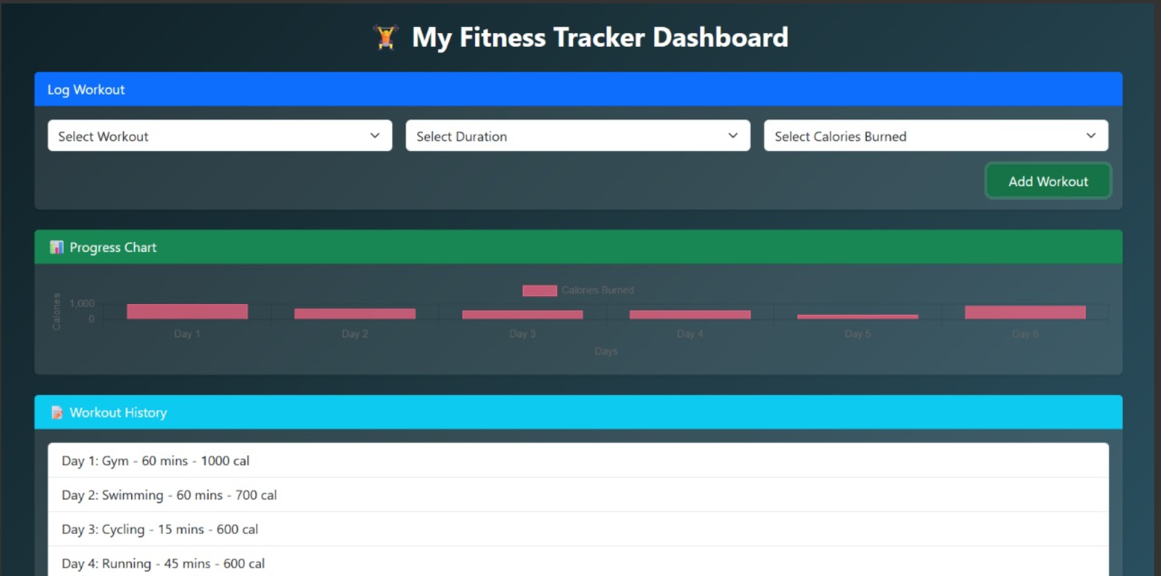

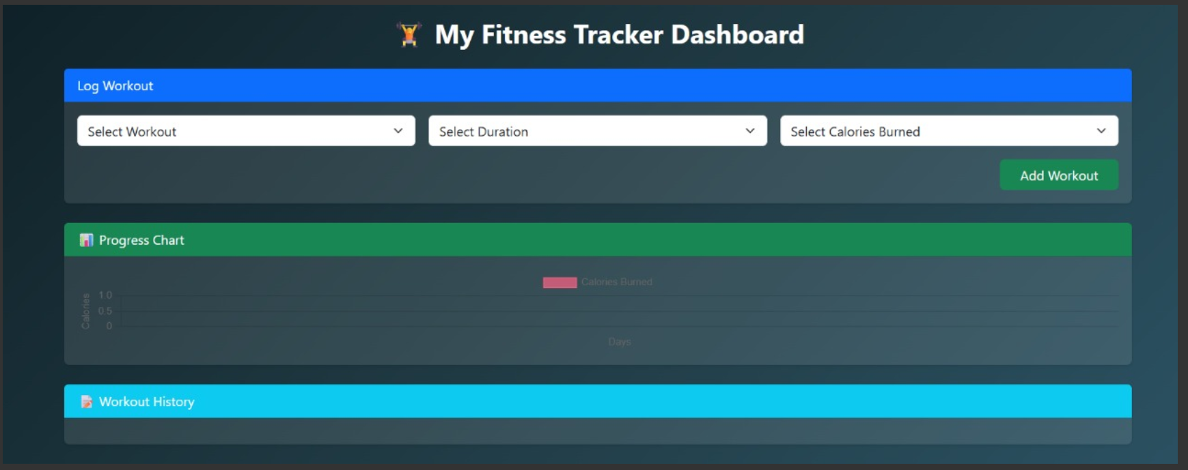

**15. Conclusion**

The Fitness Tracker Dashboard project provided practical exposure to building **interactive dashboards** with **user inputs, and responsive design**. It enhanced my understanding of JavaScript logic, Bootstrap layout, and Chart.js integration. The project demonstrates how front-end technologies can be combined to create meaningful real-world applications for fitness management.

**16. References**

* L&T EduTech LMS: <https://learn.lntedutech.com/Landing/MyCourse>
* W3Schools HTML & CSS Documentation: [https://www.w3schools.com](https://www.w3schools.com/)